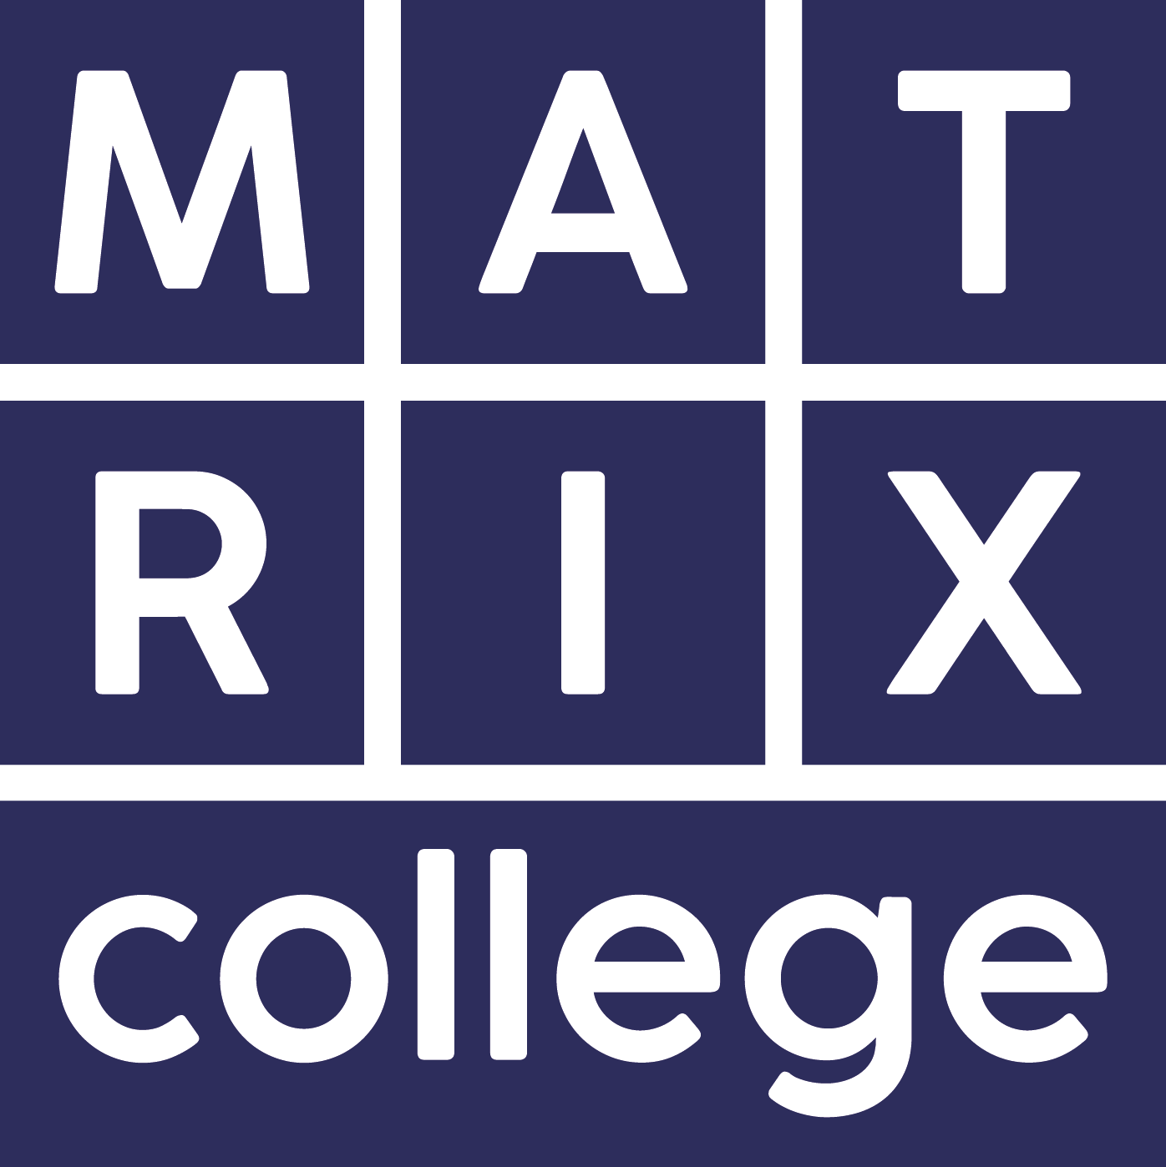

Learning Support at Matrix

As well as individual support offered by your Programme Lead, we also have a dedicated Learning Support Tutor, Henry Adeane. Henry is able to support students with specific individual needs.

As the support is targeted, the Learning Support Tutor will initially offer you a discussion to discuss your needs. Examples of support offered in the past are support with essay writing, liaising with tutors about specific medical requirements and helping with dyslexia assessments.

Dyslexia

We encourage any student who feels they may have dyslexia to have an assessment.

As a small college we are not able to assist students with dyslexia assessments. Prospective students might find a dyslexia check list useful to help decide if they should go for a full diagnostic assessment. More information is available at:
https://www.bdadyslexia.org.uk/services/assessments/assessments-vs-screening

A Dyslexia Diagnostic Assessment can cost in the region of £200 to £400. Information about the assessments and how to contact a qualified/recognised assessor on the BDA website at:
https://www.bdadyslexia.org.uk/dyslexia/how-is-dyslexia-diagnosed

Disabled students’ Allowances (DSA)

You may be able to apply for DSA support to cover extra costs you may have if you have a recognised disability. We can support you to apply for DSA funding. More information about DSA is available at https://www.gov.uk/disabled-students-allowances-dsas/overview

Students with dyslexia will need to have a full diagnostic assessment to obtain the necessary evidence of their disability before they are able to apply for DSA funding.

A DSA Assessment of Needs is carried out at a local access centre to establish what particular support a student may need.

Matrix is committed to working as effectively as possible with students with disability. Care is taken to use visual images on handouts, fonts suitable for dyslexic students are used throughout Matrix handout materials and varying teaching styles and methodologies are considered whenever possible, to meet varying learning needs and styles.

Please note: It is sometimes recommended that a student records the teaching sessions. Unfortunately, because of confidentiality issues it is Matrix policy that no teaching is ever recorded.

Unfortunately, under the terms of our validation agreement with Middlesex University students are unable to get any direct learning support from Middlesex.

Henry Adeane, our Learning Support Tutor can be contacted on henry.adeane@gmail.com

