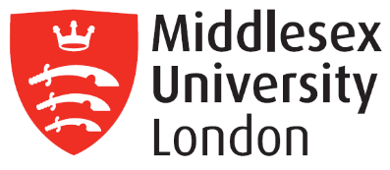
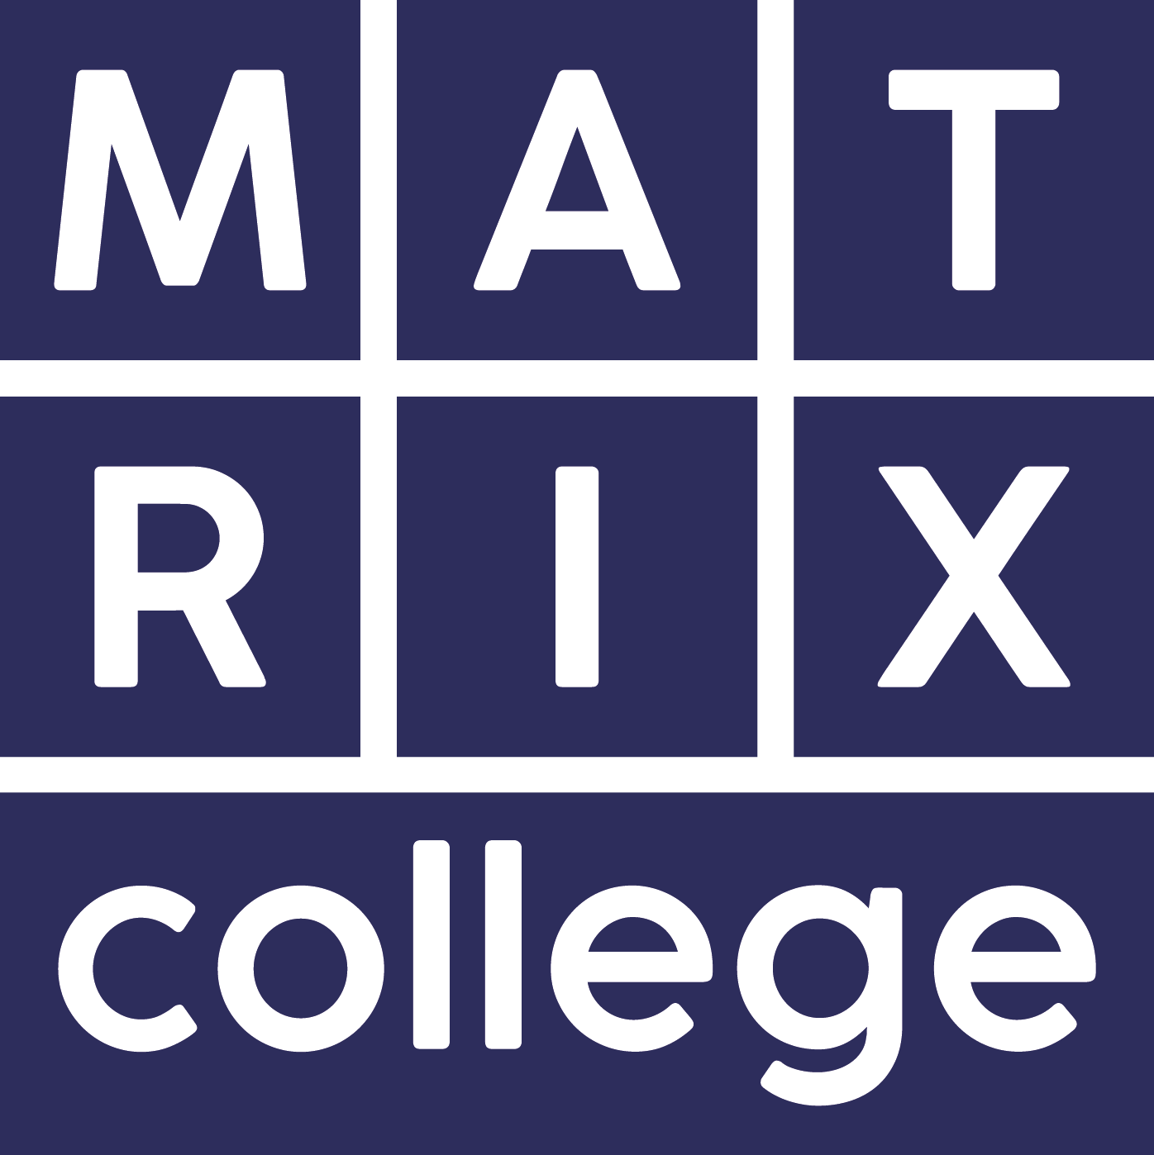

Programme Specification

Admission to the programme
Applications come from the caring professions as well as those who are looking for a change in career. We expect students have some life and work experience before beginning counselling training. Students with disability are welcomed to apply. Every avenue will be explored for their specific needs to be met.

When prospective applicants apply, and at the admission interview, they will be expected to fulfil the following criteria:

- complete the Matrix application form
- demonstrate motivation and commitment to learning and self-development
- demonstrate an ability to cope with both the academic and experiential components of the course through the completion of the application form and at interview
- write 1000 words describing personal strengths/ attributes/possible difficulties which may assist or impede training
- provide two-character references describing their suitability for training
- demonstrate personal readiness for the rigours of counselling training
- meet the APL criteria if entering at Years 2 or 3
- meet English Language of ILETS with minimum grade 6 (with 5.5 in all components).

Aims of the BSc (Hons) Programme
Learning on this programme will reflect the ability to:

- develop a rigorous approach of a broad knowledge base
- employ a range of specialised skills
- evaluate information using it to plan and develop strategies and to determine solutions to a variety of unpredictable problems
- operate in a range of varied and specific contexts, taking responsibility for the nature and quality of outputs
- generate ideas through the analysis of concepts at an abstract level, with a command of specialised skills and the formulation of responses to well defined and abstract problems
- analyse and evaluate information
- exercise significant judgement across a broad range of functions
- accept responsibility for determining and achieving personal and/or group outcomes
- critically review, consolidate and extend a systematic and coherent body of knowledge, utilising specialised skills across an area of study
- critically evaluate new concepts and evidence from a range of sources
- transfer and apply diagnostic and creative skills and exercise significant judgement in a range of situations
- accept accountability for determining and achieving personal and/or group outcomes.

Specific Aims of Year 1:

- Establish a learning environment for professional and personal growth
- Facilitate a broad knowledge base and related skills of the self/other relational framework
- Provide an understanding of the concept of integration, the history and principles of the integrative approach
- Equip with a range of specialised skills which can be used in work settings, and preparation for continuing counselling training
- Convey a psychological understanding of self and others that can be produced in both verbal and written form

Specific Aims of Year 2:

- To foster an understanding of both clinical processes and self-in-relationship with reference to relational concepts
- To prepare for, and facilitate, a counselling practice placement; working ethically, non-oppressively, with other professionals under supervision
- To enable critical evaluation in verbal, written and academic material
- To deepen skills as a reflective practitioner

Specific Aims of Year 3:

- Achievement of an understanding of what integration means in the context of individual counselling with adults, to enable the creation of an integrative philosophy that is internally coherent and personally suitable
- Achievement of a capacity to articulate, research and write about working with a fragile client with critical and rigorous self-reflexivity
- To facilitate knowledge and professional skills for outstanding and in-depth clinical practice

- Programme outcomes for the BSc (Hons) Integrative Counselling
- Knowledge and understanding  On successful completion of this programme the successful student has knowledge and understanding of:  - The concept of integration, its history and the therapeutic relationship from an integrative perspective.  - Contemporary theories of counselling including humanistic, psychodynamic and cognitive behavioural principles.  - Relational needs and subsequent impact of deficits.  - Analysis and evaluation of ethical concepts and working at relational depth.  - Critical review and progress towards the development of a coherent and rigorous personal integrative framework.  - Have an ability to analyse and understand the research processes.  - Have an ability to recognise and understand fragile client presentations.  - To build upon and consolidate an integrative framework. | Teaching/learning methods  Students gain knowledge and understanding through:  Writing essays, class discussion, reflection on life experience, reading, group process experience, journal keeping, writing research proposal, writing case studies, skills practice, didactic lectures, peer feedback (whole group, dyads and triads), tutor feedback, tutorials, personal counselling.  Assessment methods  Students’ knowledge and understanding is assessed by:  Continuous assessment:  Tutors’ observation and feedback from: class discussion, skills practice, group process. Reflections on self from personal counselling and tutorials, self-learning log.  Summative assessment:  Learning journal, essays, self and peer assessment, book presentation, framework paper, supervision reports, external assessments.
- Cognitive Skills  On successful completion of this programme, you will be able to:  - Develop your ability to integrate ideas and concepts rationally from different theoretical approaches to counselling.  - Formulate ideas and construct arguments underpinning them with theory.  - Critically reflect on your own philosophy of theory and practice.  - Apply and critique theoretical perspectives to clinical issues and understand how theory links to practice.  - Build on skills of linking research information to practice.  - To use research methodology to write a mock proposal. | Teaching/learning methods  Students learn cognitive skills through:  Writing essays, research proposal and case studies, class discussion, reading, group process experience, group supervision, journal keeping, skills practice, didactic lectures, peer feedback (whole group, dyads and triads), tutor feedback and tutorials, personal counselling and supervised practice placement.  Assessment methods:  Students’ cognitive skills are assessed by:  Continuous assessment:  Observation and feedback from tutors on class discussion, skills practice, group process, self-learning from personal counselling and tutorials, self-learning log.  Summative assessment:  Learning journal, essays, self and peer assessment, presentations
- Practical Skills  On successful completion of the programme you will be able to:  - Demonstrate listening and key counselling skills in skills practice and process group.  - Receive and give constructive feedback and develop some self-reflective skills.  - Work co-operatively and non- oppressively in a multi- disciplinary team.  - Show a range of practitioner skills demonstrating competence, expertise and professional ethics.  - Demonstrate a self-reflective and non-oppressive attitude to clinical practice.  - Understand the complexity of human communication and make informed choices in response to these.  - To show ability to work clinically at relational depth. | Teaching/learning methods  You will learn practical skills through:  Skills practice in triads, observed skills practice and placement.  Giving and receiving peer feedback, tutor feedback, self-reflection and personal counselling.  Further practical skills are learnt through class presentations, engaging in class activities and  class discussion, and through the process of seeking and finding information.  Students’ practical skills are assessed by:  Continuous assessment:  Tutors’ observation and feedback from skills sessions, group process, supervision.  Summative assessment:  Supervision reports, essays, external assessments.
D. Graduate Skills  On successful completion of this programme, you will be able to:  - Show an ability to learn from, and communicate ideas about theory and practice to your peers and tutors.  - Demonstrate a high level of counselling skills by practising in experiential exercises and skills practice in triads.  - Use a library and write material to the standard of Higher Education, show that you can assume responsibility for own learning and request assistance appropriately  - Follow up a line of enquiry and generate comparative ideas while showing a deep appreciation of ethical issues and working relationally in practice.  - Demonstrate critical evaluation, compare and analyse complex theoretical issues.  - Be able to practice professionally and ethically. | Teaching/learning methods  Students learn graduate skills through:  Classroom teaching, writing academic essays, journal keeping, a research project, class discussion, reflection on life experience, reading, group process work, skills practice, peer feedback (whole group, dyads and triads), tutor feedback and tutorials, group supervision, supervised clinical practice and personal counselling.  Assessment methods  Students’ graduate skills are assessed by:  Continuous assessment  Observation and feedback from tutors on class discussion, skills practice, group process, self-learning from personal counselling and tutorials, self-learning log.  Summative assessment:  Essays and journal.  Self and peer assessment, book presentation, 80% attendance, meeting the requirement of personal counselling hours. framework paper, presentation case studies and external assessment with independent assessor

Levels and modules of BSc. (Hons) Integrative Counselling
COMPULSORY MODULES.  Level 4, Year 1  Students must take all of the following:  Module 1: Introduction to Integrative principles and self-awareness  Module 2: Introduction to counselling theories and skills  Module 3: Practitioner reflexivity and professional ethics | PROGRESSION REQUIREMENTS  80% attendance  Completion of the Year 1 portfolio  5 hrs personal counselling hours may be carried over to Year 2 at the discretion of the Head of Training and support from tutors
COMPULSORY MODULES.  Level 5, Year 2  Students must take all the following:  Module 4: Working at relational depth  Module 5: Intersubjectivity and the development of the self  Module 6: Deepening personal process in counselling | PROGRESSION REQUIREMENTS  80% attendance  Completion of the Year 2 portfolio apart from:  Clinical hours:  Students are expected to be settled in a placement and have done 20 hours clinical practice with a completed supervisor’s report. The remaining supervised counselling practice hours may be carried over to the following 12 months  10 hrs personal counselling hours may be carried over to Year 3 at the discretion of the Head of Training and support from your tutors
COMPULSORY MODULES  Level 6, Year 3  Students must take all of the following:  Module 7: Co-creation of the therapeutic relationship  Module 8: The fragile client  Module 9: Further developing reflective practice | PROGRESSION REQUIREMENTS  80% attendance  The case study can be submitted within 1 year of completion of the taught programme  Supervised clinical practice hours may also be completed over the following 12 months at the discretion of the Head of Training

Placement opportunities, requirements and support
We expect students to become a trainee member of the UKCP or BACP before starting to practice with clients, and agree to observe the UKCP Code of Ethics. As a student of Matrix, you are also obliged to agree and adhere to Matrix College Code of Ethics.

Students are required to have indemnity insurance when in practice. A placement agency may have insurance, if the agency does not cover this you will need to get your own personal insurance. The Deputy Head of Training can support you to find this, you will need to fund personally.

Matrix has links with many placements within many East Anglian service providers. In line with PCICP (UKCP) guidelines, these placements may cover the provision of adequate and appropriate levels of integrative counselling supervision (as distinct from managerial supervision) and possibly professional indemnity insurance.

Future Careers
Matrix staff are available to give references. Students are requested to inform their tutor if they require one before revealing contact details. Networking with agencies and services in the community is considered to be an important part of the student’s learning in future career development both as a student and graduate. Programme Leads are always available to discuss career possibilities and potential. This takes place specifically in individual tutorials throughout the training under the PDP Personal Development Plan.

Opportunities for those exiting with the award of Cert HE:
This programme equips students with vital counselling skills, which are useful in any job which requires them to have communication with people. It will also enhance promotion prospects. For instance, students may be working in the field of teaching, police force, nursing, sales or customer relations. A skills course at this level is a prerequisite for all professional counselling trainings and students may wish to continue into Year 2 of the BSc. (Hons) to follow this career path.

Opportunities for students exiting with the Dip HE:
Former students who have previously exited with the Dip HE have made successful careers with counselling agencies.

Opportunities for graduates exiting with BSc
Former Matrix BSc graduates have gone on to work in a variety of settings that include:
- eating disorders services
- child and family services
- services for older adults
- services for those with learning disabilities
- prison and probationary services
- social services
- voluntary organisations
- student counselling services
- primary care
- community mental health teams
- general health settings where psychological well-being services are offered
- private practice

Qualification at this level enables the graduate to apply for psychotherapy training at Master’s level.

Relevant QAA subject benchmark
Subject Benchmark Statement for Counselling and Psychotherapy 2013

http://www.qaa.ac.uk/en/Publications/Documents/Subject-benchmark-statement-counselling-psychotherapy.pdf

Reference Points
QAA - The Framework for Higher Education Qualifications in England, Wales and Northern Ireland (FHEQ) (August 2008)

UKCP Standards for Education and Training for Psychotherapeutic Counsellors

